The company needs the following in order to have an attractive corporate identity:

* Logo
* Tagline
* Stationary (business card – Letterhead – Envelopes)
* Corporate flyer – brochure to explain how to sort the garbage
* Uniform
* Office banners
* Signage
* Truck branding
* Garbage drums
* Classifying garbage labels

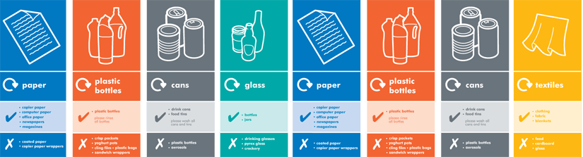

* Yearly campaign
* Website
* “ What we do”

